**Lab Assignment 1: Reverse engineer the design of an opamp LM741**

All question material is in blue. Please put your answers in black color font

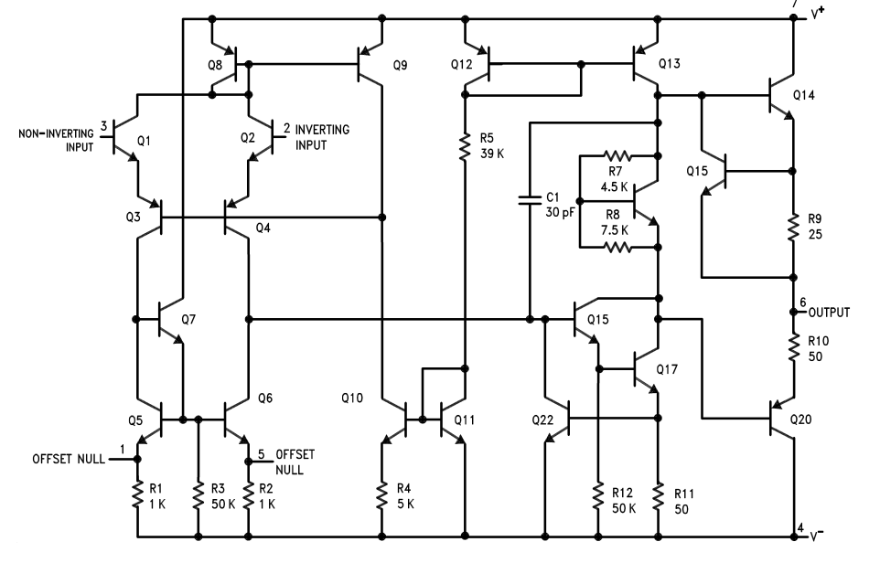

**V+**

**V-**

**OUT**

Fig 1

The above diagram, taken from the datasheet of the LM741 opamp IC shows the internal functional block diagram of the IC as discussed in Session 1

An opamp is a three terminal device – the generic LTSpice symbol for an opamp, and its basic governing equation is:

$$VOUT=G*\left(V_{+}-V_{-}\right) with G\sim {10}^{6}$$

Input impedance at V+ and V- is ∞, i.e. no current goes into those two terminals

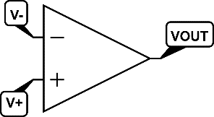

At this point, *don’t* consider the reasons why connecting a pair of external resistors in feedback loop brings the unusably high open-loop gain to some specified design value.

Answer the following questions:

**Question 1: 20 marks for 20 transistors Q1 – Q20!**

There are twenty transistors shown in Fig 1. Some are NPN, some PNP. Many seem to be configured in pairs.

Identify the function performed by each of these 20 transistors. An even number of bullet points are expected for the answer: 20 transistors – even number if some of the transistors are acting as a pair.

For example, it was discussed briefly in the session that Q10+Q11 function as a current mirror: your answer must indicate what is the use of the current set by this current mirror?

Q1: npn Emitter follower, connected to non-inverting input

Q2: npn Emitter follower, connected to inverting input

Q3 and Q4: pnp in common base mode. Responsible for isolating both the inputs.

Q5, Q6 and Q7: Responsible for balancing any irregularities at the input side, by taking in offset nulls. Q6

Q8, Q9, Q12 and Q13: Form 2 current mirror circuits. The current mirrors ensure that only the required current flows. Q8 & Q9 are coupled to the input circuit, and Q12 & Q13 are coupled to the output circuit.

Q10 and Q11: Another current mirror, which provides reference voltage without loading the input and sets the slight base bias current required by the pnp transistors at the input common-base amplifier circuit.

Q14, Q17 and Q20: Forms the output stage of the amplifier.

Q16 (not labelled in the diagram that was shared in class): Combination of Q16, 4.5kΩ and 7.5kΩ functions as a voltage shifter level circuit. It drops the voltage from input amplifier circuit by 1V before it is sent to the succeeding circuit. This is done to prevent signal distortions at the output amplifier stage.

Q15 and Q19: Single switching transistors that operate in common emitter mode (i.e. Class-A type).

**Question 2: Voltage or Current output? 5**

Is the output from the opamp a Voltage or Current output?

The output from the OpAmp is a **Voltage output**. In fact, from the configuration it is clear that we use such an OpAmp to get a high voltage gain from it.